Alternative rock project THE HYBRIS set to release new single “The Game Of Cat And Mouse” // OUT 19th May

LISTEN HERE // PRESS PICTURES HERE HERE
FFO: Killers, My Chemical Romance, Joy Division

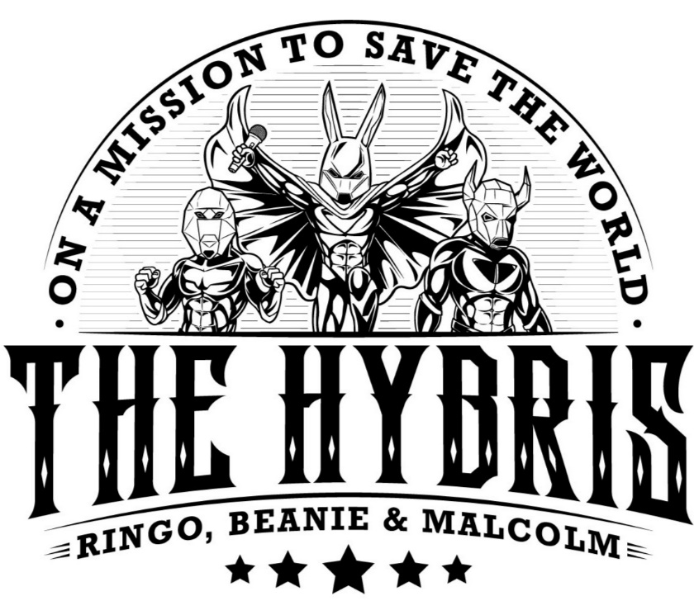
THEHYBRIS.COM
INSTAGRAM
TWITTER
Originally hailing from Germany, alternative rock project THE HYBRIS now stretches to the edges of the globe with members in Nice, L.A. and Cologne. For their third single of 2023 the band is set to release a new track entitled “The Game Of Cat And Mouse”. The song features dialled in guitar tones and a driving drumline all topped with vocal performances that come as energetic and dynamic. Raw, acute and entertaining, THE HYBRIS have everything it takes to produce an infectious, quintessential alternative rock track - from their attitude all the way to their sound.
When speaking on the new release, the band says, “This next single is about social disparity and injustice, one of the greatest and ever-growing evils of our time. This song will also be part of our second album, which will be released towards the end of the year.”
The group takes on the aliases of Ringo Rabbit, Beanie Bison and Malcolm Mandrill, three wannabe comic superheroes on a mission to save the world. Having a group to be on the up and up whilst so engaged with this conceptual aspect is a sure sign of future success. With their name itself, ‘Hybris’, refers to Greek tragedy, being a term that stands for exaggerated self-pride, arrogance, excess of ambition leading to self-destruction. The band were commenting on the current state of the world from the start and only continue to do so in their musical and lyrical content.
This song teases their second full-length album, we can only wait in excitement to see what THE HYBRIS have to offer for us in the coming year. A project that is so sure of itself, the band is one to watch for the future of alternative rock.

For press enquiries please contact hello@thehybris.com

